VIDEO STREAMING APPLICATION

Introduction
- The project titled Video Stream Application is a software for maintaining the streaming content of the OTT platform WEBFLIX. This project mainly focuses on basic operations like showing all the list of the available videos, searching the videos based on id or genre or duration more than 10 minutes.

Design and Detailed technical updates

Process model

Use case Model

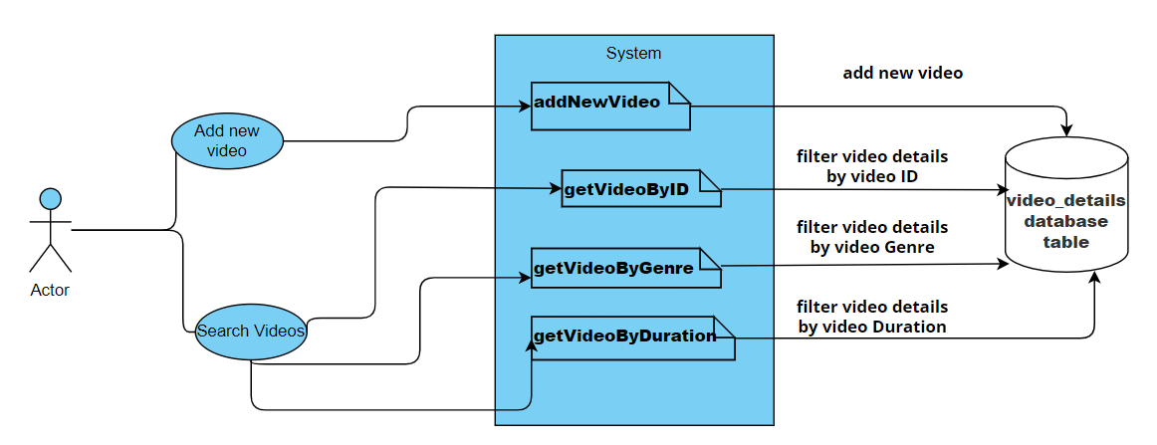

Brief Description | User search for Video Details
Basic Flow | Application can search for a video or list of Videos by three options  - Search by Video ID  - Search by Video Genre  - Search by Video Duration more than 10 minutes  Using any of these options one can search for the videos. It will display the list of video details like Video ID, Video Genre, Duration, Video Name.
Alternate Flow | The system will validate the information provided. If the video is not available then application will show an error message like Video content is not available.

4.1.2 Architecture Diagram

Layer
Logical View
Technology/ Framework

UI Components
Presentation Layer
HTML5/ thymeleaf
VideoDetails
Home

Web-Server Classes
Java 1.8/Spring boot 2.6.4
Application/ Business Layer
Configuration
Controllers

Service
ExceptionHandlersrsrsrr

Entity/ Model Classes

Data Access Layer
Repository classes
Spring Data JPA

MySQL Database

4.3 Database design changes

4.3.1 ER Diagram

